Oracle database Administration Services
Database Startup and Shutdown
Submitted to



By



CIS, Wipro Limited

Document Details

Project Name | Innogy SE
Account | CIS
IT Component/Application Title | Database Start and shutdown
Current Version | 1.5
List of Contributors | Chetan Patel, Saurabh Nigam, Jitenkumar Pansara, Sreya Puthukudy
Customer Contact Information

Version History
(All revisions made to this document must be listed in chronological order. All revisions must be approved. Review and Approval can be done by an internal source or by the customer)
Version | Date of Revision | Description | Author | Reviewed By | Approved By
1.0 | 01-06-2015 | Intial Draft | Chetan Patel | Saurabh Nigam | Mahesh Keshatwar
1.1 | 01-08-2015 | Document Completed | Chetan Patel | Saurabh Nigam | Mahesh Keshatwar
1.2 | 21-08-2016 | Updated document to standard format | JitenKumar Pansara | Saurabh Nigam | Mahesh Keshatwar
1.3 | 17-05-2017 | Wipro and Innogy Logo changed | Sreya Puthukudy | JitenKumar Pansara | Mahesh Keshatwar
1.4 | 20-09-2017 | Updated document to Wipro Standard format with header and footer | Sreya Puthukudy | JitenKumar Pansara | Mahesh Keshatwar
1.5 | 20-12-2018 | Updated the content | Sreya Puthukudy | JitenKumar Pansara | Santosh Badiger

Document Distribution List
S.No | Name and Company | Purpose
1 | RWEIT-ORACLEDBA | This document is about the method of startup and shutdown databases.
2

TABLE OF CONTENT
1. Purpose 5
2. Scope 5
3. Database Startup Shutdown Flow Process 5
4. Steps To Start/Shutdown Database 5
4.1 Connect To The Server 5
4.2 Check for backup \ job is running 6
4.3 Check For Db Level Transaction Is Executing 6
4.3.1 Execute the topas command 6
4.3.2 Check the PID for the process 7
4.3.3 Obtain the corresponding SID And Hash Value for the PID Execute the below query and provide the PID, observed above as input 7
4.3.4 Determine the text of the query using hash value 8
4.4 Check for any user sessions logged in 9
4.5 Check for dependency of database with other database \ application 9
4.6 Database startup 10
4.7 Database Shutdown 10
5. Reference 10

Purpose
This document is prepared for Startup & shutdown of oracle database and listener of Oracle Database Administration Services at RWE GBS UK.

Scope
This document is prepared for RWE GBS UK Wipro sustenance team and provides the concepts of for Startup & shutdown of oracle database and listener at Linux at RWE GBS UK.

Database Startup Shutdown Flow Process
The below sheet contains the flow for Database Startup Shutdown Flow Process:
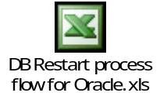
Note: The above flow is a draft. It is required to be modified on the customer discussion.

Steps To Start/Shutdown Database

Connect To The Server
Step 1: Double click on putty.exe

Step 2: Type the host name of the server and select telnet. Then press ok.

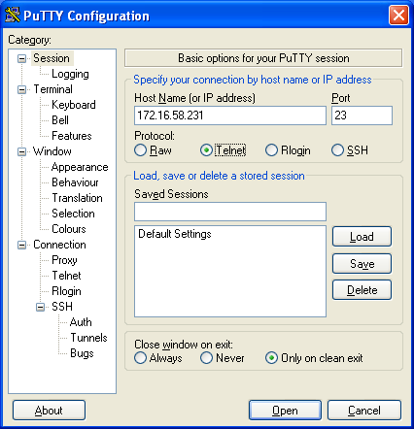

Step 3: It will ask for username and password. Give username and password.

Check for backup \ job is running
Refer the start time; end time and log file for checking the status of job execution.

Check For Db Level Transaction Is Executing

Execute the topas command

Check the PID for the process
Now check for the PID of the process with high CPU consumption

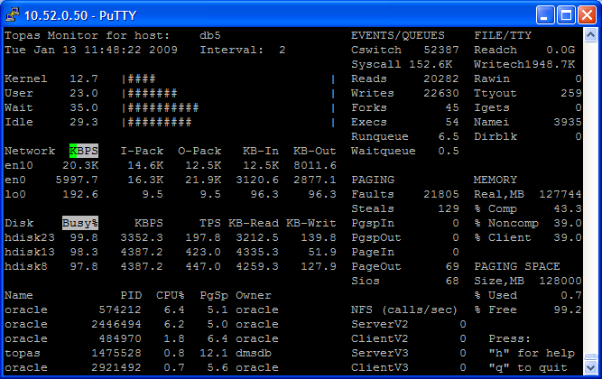

Obtain the corresponding SID And Hash Value for the PID Execute the below query and provide the PID, observed above as input
select S1.sid ,s1.serial#,s1.status,s1.SQL_HASH_VALUE,s2.sql_text from v$process p,v$session s1,v$sqlarea s2
where p.addr = s1.paddr and s1.SQL_HASH_VALUE = s2.HASH_VALUE
and p.spid=&spid;

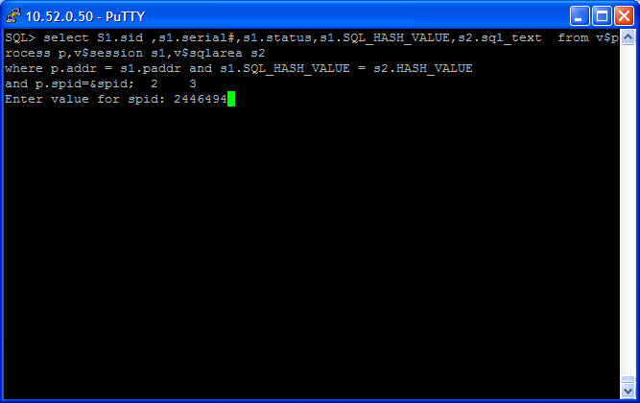

The output of the query as follows

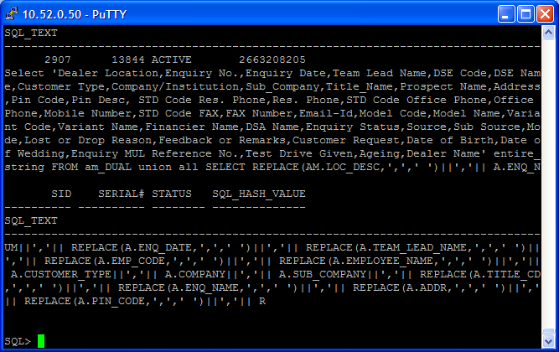

Determine the text of the query using hash value

SQL> select sql_text from stats$sqltext where hash_value in ('&hash') order by hash_value, piece;
Enter value for hash: 2301379024
old 1: select sql_text from stats$sqltext where hash_value in ('&hash') order by hash_value, piece
new 1: select sql_text from stats$sqltext where hash_value in ('2301379024') order by hash_value, piece

SQL_TEXT
----------------------------------------------------------------
SELECT BIN_LOC FROM PM_STOCK_BIN_LOC WHERE PARENT_GROUP = :B6 AN
D DEALER_MAP_CD = :B5 AND LOC_CD = :B4 AND STORES_CD = :B3 AND P
ART_NUM = :B2 AND COMP_FA = NVL (:B1 , COMP_FA)

Check for any user sessions logged in
Execute the below query to check the users logged in.
SQL> select user#,username from v$session;

USER# USERNAME
---------- ------------------------------
0
0
0 SYS
0
0
0
0
0
0
0
0

USER# USERNAME
---------- ------------------------------
0
0
0

14 rows selected.

SQL>

Check for dependency of database with other database \ application
Refer the Application Database Dependency for same.

Database startup
LISTENER Startup
$lsnrctl
$lsnrctl>start LISTENER

Starting the database
$ sqlplus “/ as sysdba”
SQL>startup
Instance Started
Database Mounted
Database Open

Database Shutdown
Stopping the database

$ sqlplus “/ as sysdba”
SQL>shutdown immediate
Database Closed
Database Dismounted
ORACLE instance shut down

LISTENER Shut Down
$ lsnrctl
$ lsnrctl>stop LISTENER

Reference
- http://www.dba-oracle.com/concepts/db_startup_shutdown.htm

